Galion City Schools
Board Report
January 10, 2013

Preparing Teachers for Student Growth Measures
&
Future Evaluation System (OTES)

Upcoming Training will be conducted in January and February to provide districts with the training tools to use in meetings and professional development sessions this spring.

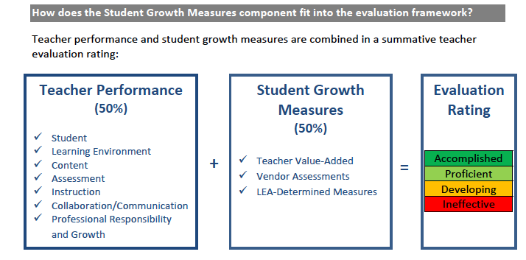

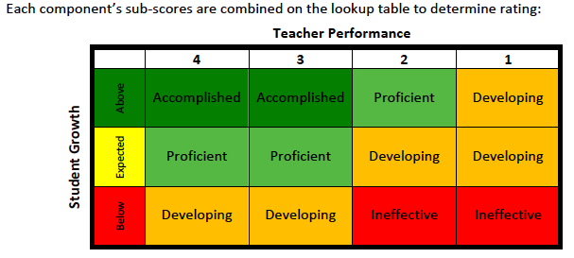

Choices School Districts Can Determine:

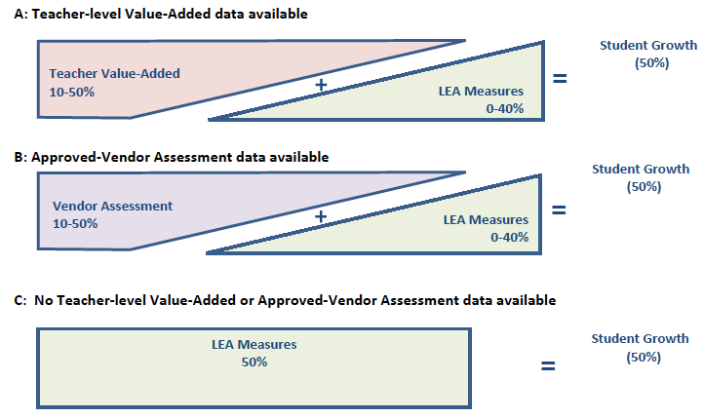

January 18, 2012 District Wide In-service
Teachers & Administrators
Galion Middle School
8:30 – 11:30 a.m.

Session Topics:
Google Docs 101

Designing Assessments w/Google Doc Forms

iPad App Evaluation & Recommendation for 13-14 School Year
AVID: Understanding this College Readiness System

Moving to Digital Textbooks: The Future is Now (Gr. 6-12)

Standards-Based Report Cards:
Grade 3 Development
Protecting Your Money & Your Health Benefits

