LRPE Teacher Information

What is LRPE?
LRPE stands for “learning readiness physical education.” It was developed based on the latest neuroscience research that overwhelmingly shows that brain function is much higher after exercise.

Why have LRPE?
3 GOALS
- IMPROVE ACADEMIC PERFORMANCE
- IMPROVE CLASSROOM BEHAVIOR
- IMPORVE PHYSICAL FITNESS

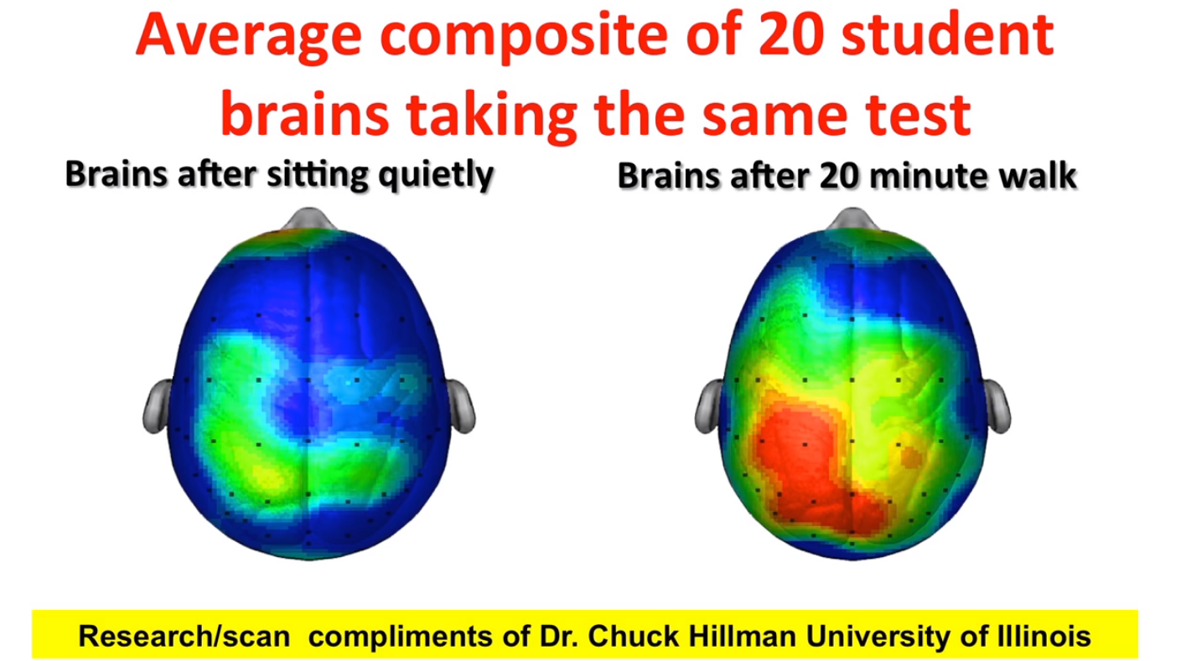

Hormones released after exercise and their effects:
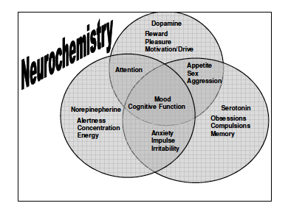

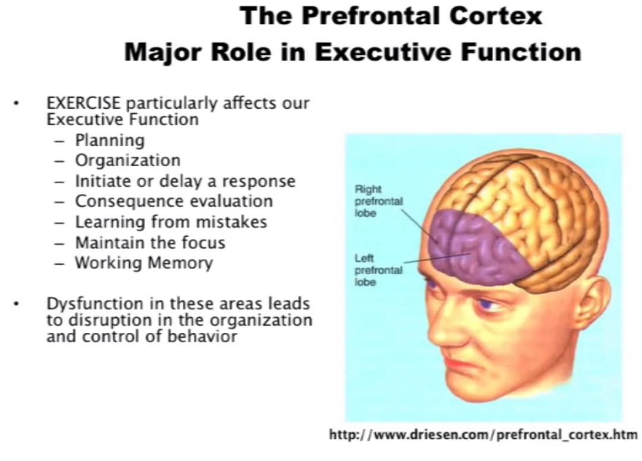

What will our program will look like?
- 25-30 minutes of daily physical activity that is engaging, fun, and individually focused.
- All fifth grade students and staff will use a piece of technology called a Movband which tracks steps, miles, and moves (similar to a Fitbit).
- On Mondays, Wednesdays, and Fridays students will head to the gym or outside to exercise with the specific goal to accumulate mileage. Students will be encouraged to work as hard as possible, yet at their own pace, to encourage increased heart rate which, in turn, creates the increased brain activity that will support better learning post exercise.
- On Tuesdays and Thursdays students will participate in a variety of different activity ranging from circuit strength training to free play.
- After every workout session, students will log how many miles they accumulated on a personal data sheet. At the end of the week, students will add their mileage and compare it to the goal they set at the beginning of the week.
- Ideally, all fifth grade staff would participate in the program as well for three reasons: 1) physical fitness, 2) increased brain function (creativity, mood, etc.), and 3) to model, motivate, and encourage their students to continue to work hard
- An incentive program is being developed for individual, class, and whole group achievements.
- Finally, throughout the whole year we will be collecting data in the following areas:
    - Academic growth
    - Discipline
    - Attendance
    - Physical Fitness

Resources
(Please take time to review some or all of these videos, websites, and presentations)

https://www.youtube.com/watch?v=V81cO8xyMaI&feature=youtu.be

https://www.youtube.com/watch?v=hBSVZdTQmDs

https://www.youtube.com/watch?v=Dl5kuaU5kxQ

http://www.johnratey.com

http://www.learningreadinesspe.com

http://www.johnratey.com/files/Exercise%20and%20the%20brain/INTROduction%20%20FOR%20CALIFORNIA%201.pdf

http://www.johnratey.com/files/Exercise%20and%20the%20brain/Introduction%20to%20exercise%20California%202.pdf

http://www.johnratey.com/files/Exercise%20and%20the%20brain/la%20county%20learning%20FOR%20WEB%201.pdf

http://www.johnratey.com/files/Exercise%20and%20the%20brain/la%20county%20learning%20FOR%20WEB%202.pdf

